USER MANUAL
TaxReady
Know your tax before you file
Version 6.1 | By CA Jatin Chauhan

TaxReady is a Windows tool that gives your client an early estimate of the tax payable, so the client is ready for the payment and has time to arrange the funds. It downloads the client's Annual Information Statement (AIS), works out the tax under the old and the new regime, prepares a Word report and emails it to the client.
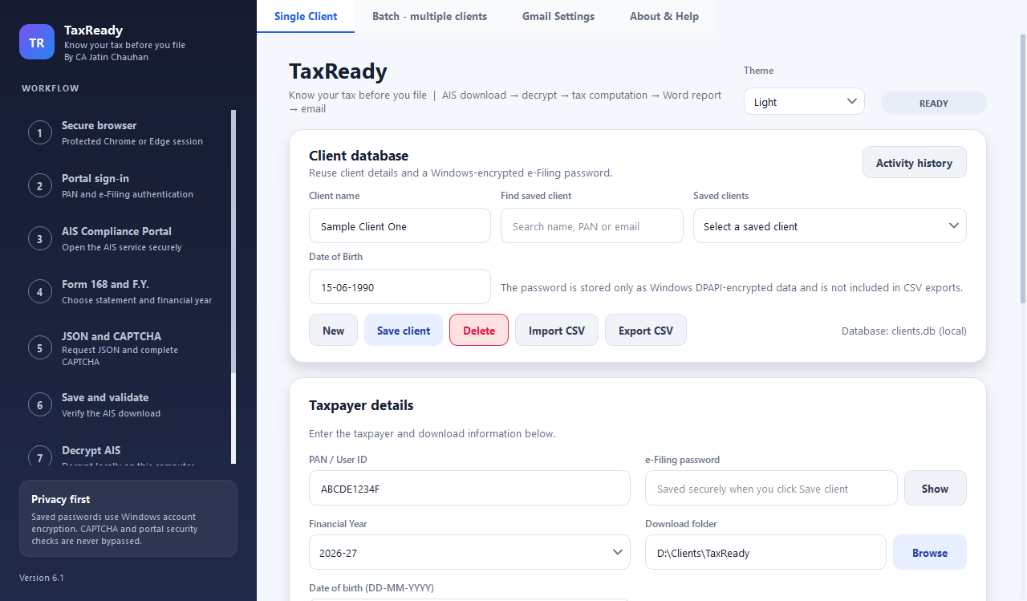
Figure 1: The TaxReady window (screenshots in this manual use sample data)

Important
TaxReady produces an estimate from AIS data only. It is not a filed return, not tax advice and not a professional opinion. Verify the figures against the official Income Tax portal and your records, and consult a Chartered Accountant before filing. TaxReady never files anything.

Contents
1. About TaxReady 4
1.1 The problem it solves 4
1.2 What TaxReady does 4
1.3 Who it is for 4
1.4 What it does not do 4
2. Before you start 5
2.1 What you need 5
2.2 Install and first launch 5
3. The TaxReady window 6
3.1 The side panel 6
3.2 The tabs 7
3.3 Top of the page 7
4. First-time setup 7
4.1 Connect Gmail (only to email reports) 7
4.2 Add your clients 8
4.3 Import clients from a CSV file 10
5. Running one client 11
5.1 The fields 11
5.2 Start the run 11
5.3 Stop a run 11
5.4 When the run finishes 11
6. The review and edit window 12
6.1 Summary tab 12
6.2 AIS income tab 13
6.3 Capital gains tab 14
6.4 Inputs and deductions tab 15
6.5 The buttons 17
7. Running many clients (batch) 17
8. The Word report 18
9. The email the client receives 21
10. How the figures are worked out 21
10.1 Which AIS lines are used 21
10.2 Heads of income 22
10.3 Capital gains 22
10.4 Tax computation 22
11. Client register, history and themes 23
11.1 Activity history 23
11.2 Themes 24
11.3 About & Help 24
12. Privacy, security and where data is kept 24
13. Troubleshooting 25
14. Frequently asked questions 26
15. Limitations and disclaimer 26
Appendix A Glossary 27
Appendix B Client CSV layout 27
Appendix C Checklist before you send a report 28

1. About TaxReady

1.1 The problem it solves
Clients are often not prepared for the tax amount they have to pay. They learn the figure only when the return is being prepared, close to filing, so there is little time to arrange the money and the payment becomes a last-minute rush.

1.2 What TaxReady does
TaxReady gives the client an early, clear estimate from the AIS, so the client is informed, funds are arranged and the tax is paid on time. For every client it:
1. Downloads the AIS from the official Income Tax portal in your own Chrome or Edge window. You complete the CAPTCHA.
2. Decrypts the file on your computer using the client's PAN and date of birth.
3. Computes the tax - income by head, capital gains, deductions, old and new regime, rebate, surcharge, cess and taxes already paid.
4. Lets you review and edit the figures before anything is sent.
5. Saves a Word report in the client's folder and emails it to the client through Gmail.

1.3 Who it is for
Chartered Accountants, tax consultants and their staff who prepare income-tax returns for several clients and want to tell each client early how much tax is likely to be payable or refundable.

1.4 What it does not do
- It does not file returns and does not log in to any part of the portal other than the AIS service.
- It does not bypass the CAPTCHA. You always complete it yourself.
- It is not tax advice. It works only from the AIS, so figures must be reconciled with Form 26AS, bank statements and other records.
- It does not compute interest under sections 234A, 234B and 234C or the fee under 234F.
- It runs on Windows only.

2. Before you start

2.1 What you need
Table 1: What you need before the first run
Item | Details
Computer | Windows 10 or Windows 11. Saved passwords are protected with Windows encryption, so TaxReady works on Windows only.
Python | Python 3.11 or newer (tested on 3.14). Download it from python.org and tick Add Python to PATH during installation.
Browser | Google Chrome or Microsoft Edge, already installed. TaxReady drives the browser you have; nothing extra is downloaded.
Internet | Needed to reach the Income Tax portal and, if you email reports, Gmail.
Gmail account | Only if you want TaxReady to email reports. You will create a Google App Password (section 4.1).
Client details | For each client: name, PAN, e-Filing password and date of birth. The email address is needed only when emailing.

2.2 Install and first launch
1. Install Python from python.org (tick Add Python to PATH).
2. Copy TaxReady.py to a folder on your computer.
3. Open the file in IDLE and press F5, or open a Command Prompt in that folder and run: python TaxReady.py
4. On the first run TaxReady installs the libraries it needs by itself. This can take a minute; the window opens when it finishes.
If the automatic installation fails, run this one line in a Command Prompt and start TaxReady again:
pip install PyQt6 playwright python-docx matplotlib pycryptodome

Keep the manual next to the program
Place TaxReady_User_Manual.pdf in the same folder as TaxReady.py (or in a folder named docs beside it). The Open the user manual button on the About & Help tab will then open it.

3. The TaxReady window
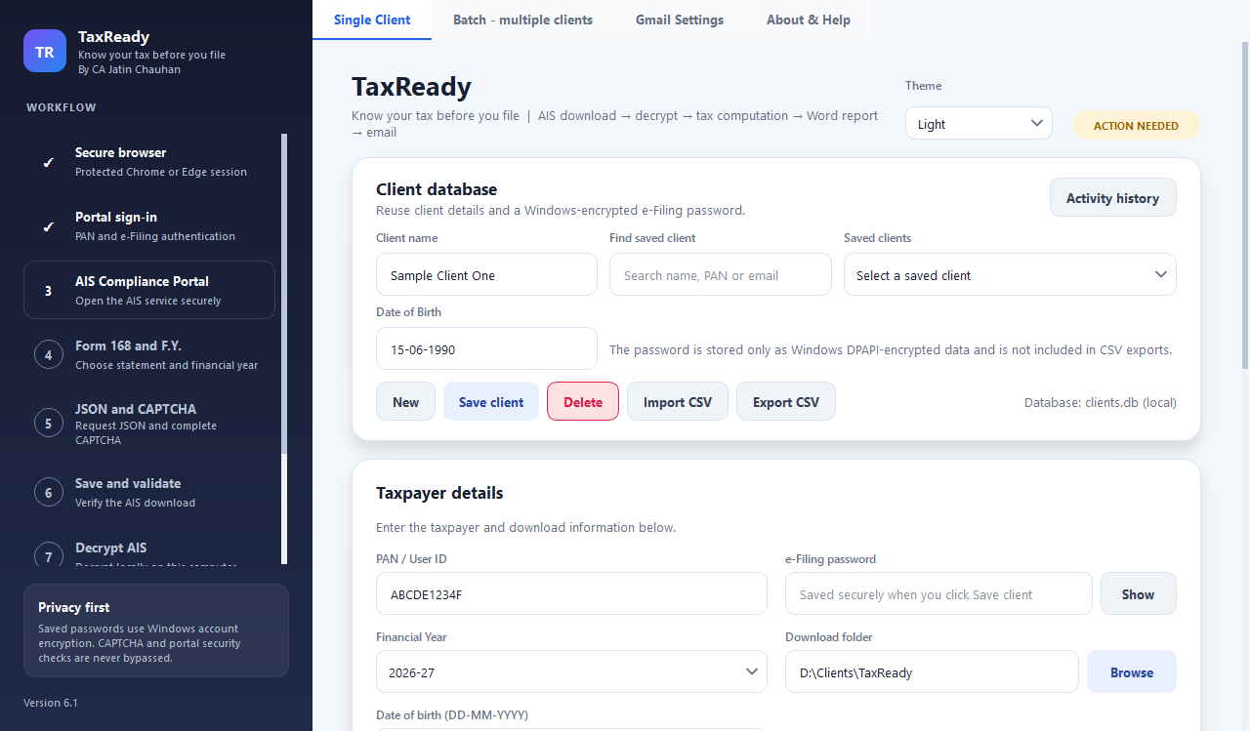
Figure 2: The window while a run is in progress: workflow steps on the left, tabs and progress on the right

3.1 The side panel
The left panel shows the nine stages of every run. Completed stages show a tick, the stage in progress is highlighted, and a stage that fails shows an exclamation mark. The Privacy card reminds you that saved passwords use Windows encryption and that the CAPTCHA is never bypassed.
Table 2: The nine workflow stages
No. | Stage | What happens
1 | Secure browser | TaxReady opens a protected Chrome or Edge session.
2 | Portal sign-in | Signs in with the client's PAN and e-Filing password.
3 | AIS Compliance Portal | Opens the AIS service.
4 | Form 168 and F.Y. | Chooses the statement and the financial year.
5 | JSON and CAPTCHA | Requests the JSON download; you complete the CAPTCHA.
6 | Save and validate | Checks that the downloaded file is a genuine AIS file.
7 | Decrypt AIS | Decrypts the file on your computer.
8 | Tax computation | Works out income and tax under both regimes.
9 | Report and email | Saves the Word report; sends the email after your review.

3.2 The tabs
Table 3: The four tabs
Tab | Use it to
Single Client | Save clients, run one client, and see the progress and activity log.
Batch - multiple clients | Run many saved clients one after another.
Gmail Settings | Connect the Gmail account that sends the reports.
About & Help | See the version, a quick-start summary and open this manual.

3.3 Top of the page
- Theme - choose from nine colour themes. Your choice is remembered.
- Status badge - READY, RUNNING, ACTION NEEDED (for example the CAPTCHA), COMPLETED, FAILED or STOPPED.
- Current stage and progress bar - what TaxReady is doing now.
- Activity log - progress messages. Passwords are never written here.

4. First-time setup

4.1 Connect Gmail (only to email reports)
1. In your Google account turn on 2-Step Verification.
2. Open https://myaccount.google.com/apppasswords, create an App Password and copy the 16 characters. This is not your normal Gmail password.
3. In TaxReady open the Gmail Settings tab.
4. Enter your Gmail address in Sender Gmail ID and the 16 characters (without spaces) in 16-character Google App Password.
5. Click Save & Verify Gmail. TaxReady logs in to Gmail once to check the details. The status line then reads “Saved Gmail connection”.
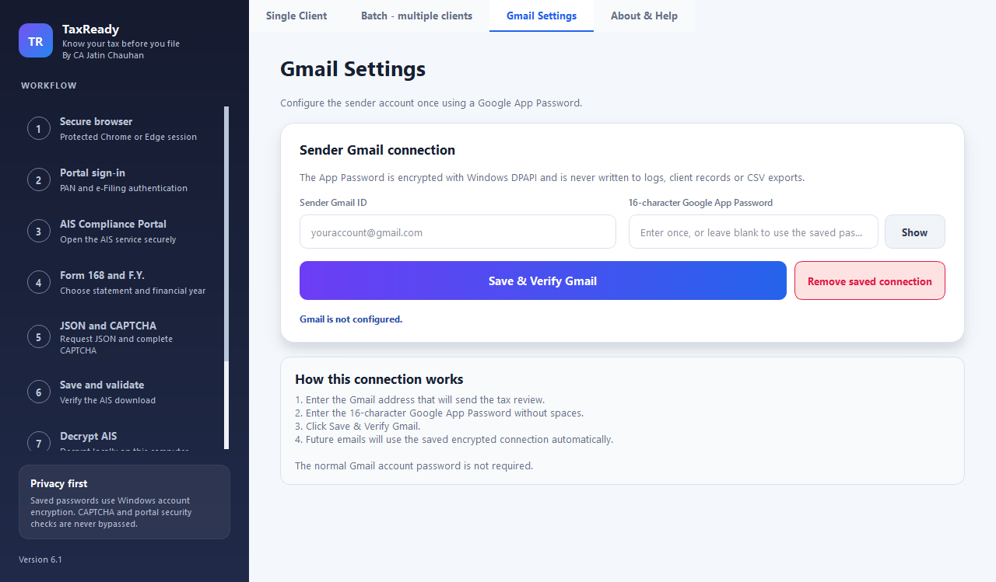
Figure 3: Gmail Settings tab
- Use Show to reveal what you typed. Leave the password box blank later to keep the saved one.
- Remove saved connection deletes the saved address and the encrypted App Password.
- The App Password is encrypted with Windows and never written to logs, client records or CSV exports.

4.2 Add your clients
Saving a client means you do not have to type the details again, and it lets the client take part in a batch run.
1. Open the Single Client tab.
2. In Client database enter the Client name and Date of Birth (DD-MM-YYYY).
3. In Taxpayer details enter the PAN / User ID, the e-Filing password, and choose the Download folder (Browse).
4. In the email panel enter the Client email ID.
5. Click Save client. A message confirms the details were saved.
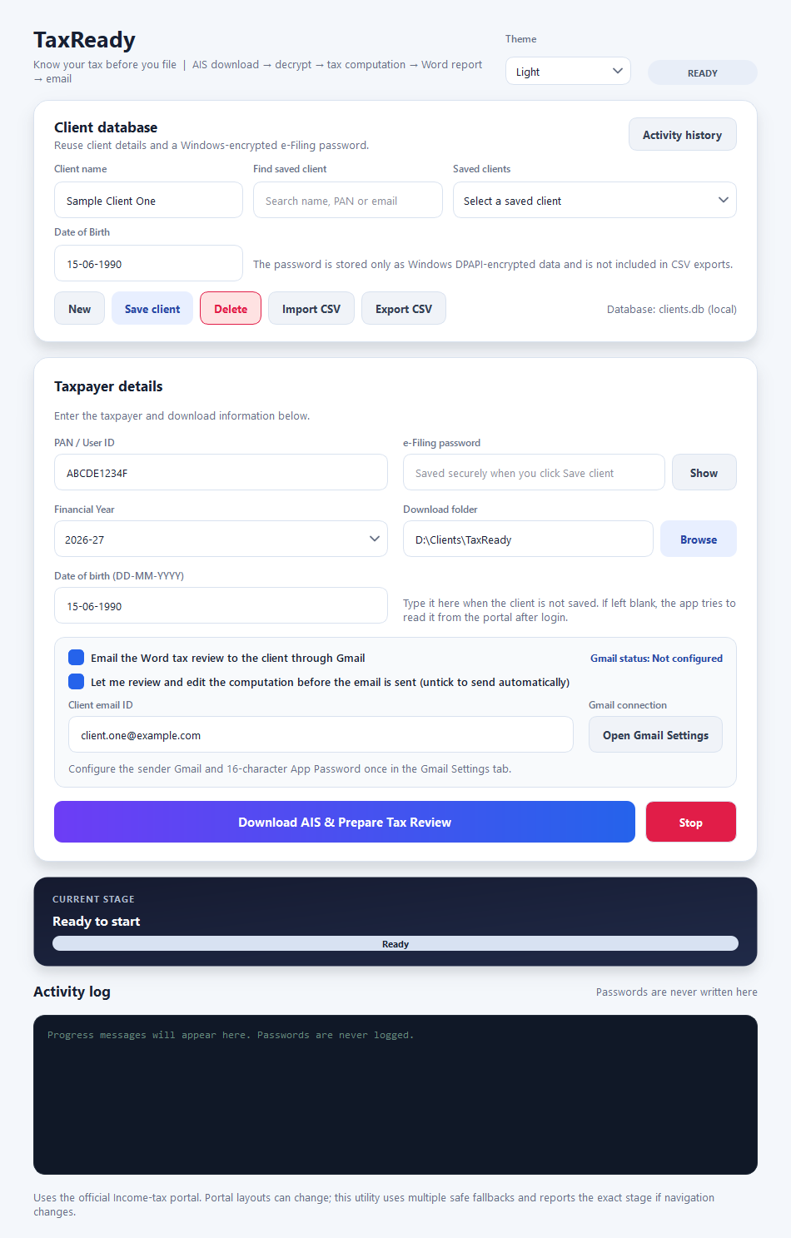
Figure 4: The Single Client page
Table 4: The client buttons
Button | What it does
New | Clears the form so you can enter a new client.
Save client | Saves the name, PAN, email, folder, date of birth and (encrypted) password. If the PAN already exists, select that client first.
Delete | Removes the selected client after confirmation. The activity history is kept.
Import CSV | Adds or updates many clients from a CSV file (next section).
Export CSV | Saves your clients to a CSV file. The Password column is left blank on purpose.
Find saved client / Saved clients | Search by name, PAN or email, then pick the client from the list to load all the saved details.

4.3 Import clients from a CSV file
Create a CSV with a header row and these columns. Column names are not case-sensitive.
Table 5: CSV columns for importing clients
Column | Required | Notes
Client Name | Yes | The client's name.
PAN | Yes | Ten characters, for example ABCDE1234F.
Email | No | Needed only when you email reports.
Date of Birth | No | DD-MM-YYYY. Needed to decrypt the AIS if the portal does not supply it.
Password | No | The e-Filing password. It is encrypted into the database during import.
Download Folder | No | The client's own folder. If empty, the folder on the Single Client page is used.
1. Click Import CSV and choose the file.
2. TaxReady reports how many clients were added or updated and lists any rows it skipped (for example an invalid PAN or email).
3. If the file contained passwords, delete it once the import is confirmed - the file itself is readable.

Sample layout
A small example file is given in Appendix B.

5. Running one client

5.1 The fields
Table 6: Fields on the Single Client page
Field or option | What to enter or choose
PAN / User ID | The client's PAN (this is also the portal user ID).
e-Filing password | The client's portal password. Use Show to check it.
Financial Year | The year of the AIS, for example 2025-26. The list starts with the current year.
Download folder | Where reports are kept. TaxReady creates sub-folders PAN, then financial year.
Date of birth | DD-MM-YYYY. Needed to decrypt the AIS. Type it here when the client is not saved. If left blank, TaxReady tries to read it from the portal after login.
Email the Word tax review... | Tick to email the report to the client when finished.
Let me review and edit... | Tick (recommended) to check and correct the figures before the email is sent. Untick to send automatically.
Client email ID | Where the report is sent.

5.2 Start the run
1. Choose a saved client, or type the PAN and password.
2. Choose the Financial Year and the Download folder.
3. Click Download AIS & Prepare Tax Review. If the date of birth is empty, TaxReady asks whether you want to enter it now or continue and read it from the portal.
4. A Chrome or Edge window opens and TaxReady signs in.
5. When the Complete CAPTCHA in browser message appears, solve the CAPTCHA in the browser and confirm the portal's download request. TaxReady then continues by itself.
6. TaxReady decrypts the file, computes the tax and prepares the Word report. If you ticked the review option, the review window opens (section 6).

Do not close the browser window
Leave the browser TaxReady opened alone until the run finishes. Closing it, or using a VPN or proxy, can make the portal refuse the session (“Permission Denied”).

5.3 Stop a run
Click Stop at any time. TaxReady ends the browser session safely and marks the run as stopped. The temporary files are deleted.

5.4 When the run finishes
1. A Tax review complete message shows where the Word report was saved and whether the email was sent.
2. The report is in <Download folder>\<PAN>\<financial year>\ and its name uses a masked PAN, for example XXXXX1234F_2025-26_AIS_report.docx. If a file with that name already exists, a date-time suffix is added; nothing is overwritten.
3. Only the Word report is kept. The downloaded AIS and the decrypted data are deleted automatically.
4. The run is added to the Activity history.

If something goes wrong after the download
If decryption or the computation fails (for example a wrong date of birth), TaxReady keeps the downloaded AIS file in the client's folder and tells you where it is, so you do not have to repeat the portal download and CAPTCHA.

6. The review and edit window
When “Let me review and edit the computation” is ticked, this window opens after the figures are computed and before anything is emailed. It is also where you correct anything AIS cannot know. Every change updates the totals instantly.

6.1 Summary tab
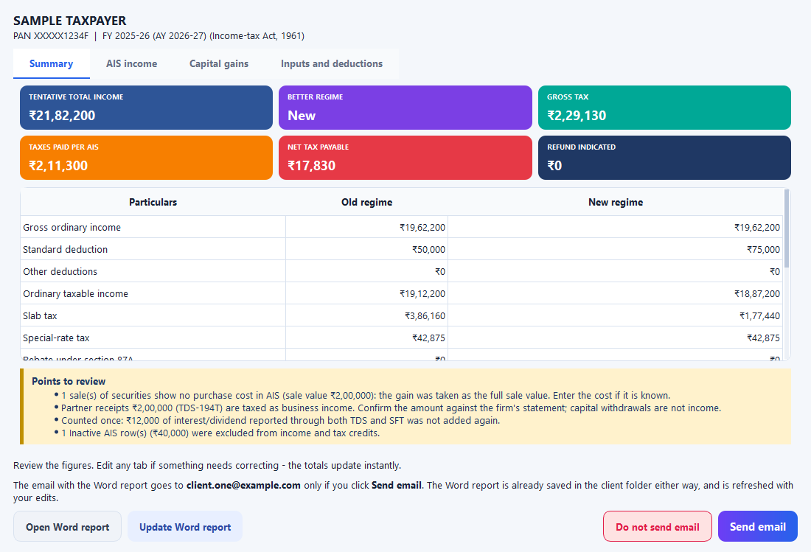
Figure 5: Review window - Summary
- Six coloured tiles: Tentative total income, Better regime, Gross tax, Taxes paid per AIS, Net tax payable and Refund indicated.
- A table comparing the old and new regime line by line.
- Points to review - the items to check first (see section 8).

6.2 AIS income tab
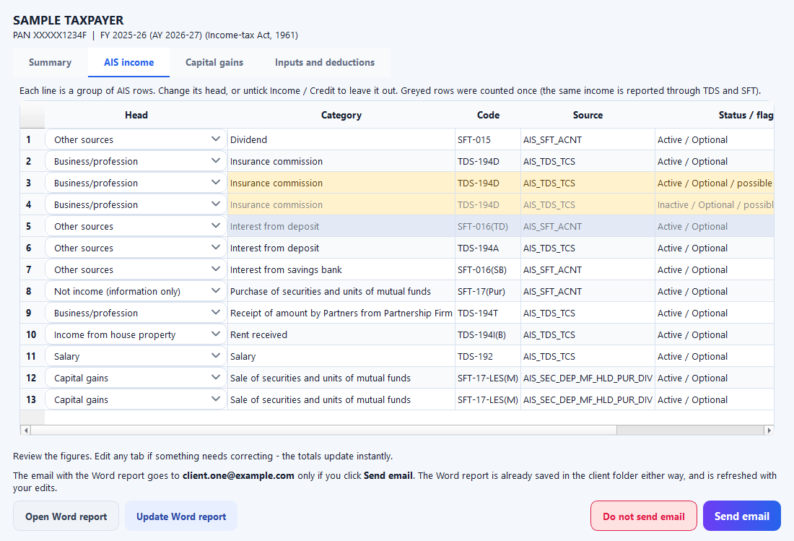
Figure 6: Review window - AIS income
Every line of the AIS is shown as a group. For each group you can:
- Change its Head (the drop-down in the first column).
- Untick Income to leave it out of the income, or untick Credit to leave out the tax deducted on it.
- Read the colours: amber = possible duplicate row; grey text = an Inactive row; blue-grey, greyed = counted once because the same income is also reported through another source (hover to read why).
Table 7: The heads you can choose
Head | Use it for
Salary | Salary income (TDS section 192).
Income from house property | Rent received.
Business/profession | Commission, fees, contract receipts and payments from a partnership firm.
Other sources | Bank interest, dividends and similar income.
Winnings (s.115BB) | Lottery and game winnings, taxed at 30%.
Not income (information only) | Reports that are not income, such as purchases of securities or cash deposits.
Unclassified | Anything not recognised. It is not counted in income until you give it a head.

6.3 Capital gains tab
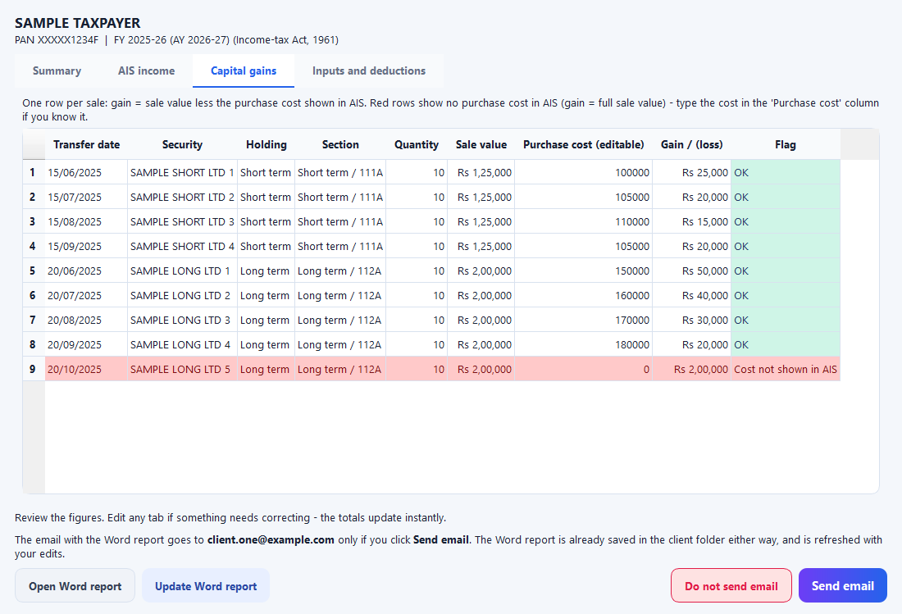
Figure 7: Review window - Capital gains
One row per sale. The gain is the sale value less the purchase cost shown in the AIS.
- A red row means the AIS shows no purchase cost (shares received as a bonus or gift may genuinely have nil cost). The gain is taken as the full sale value until you enter the cost.
- Type the cost in the Purchase cost column. The row is marked User input and the tax updates.
- Clear the cell to go back to the AIS figure.

6.4 Inputs and deductions tab
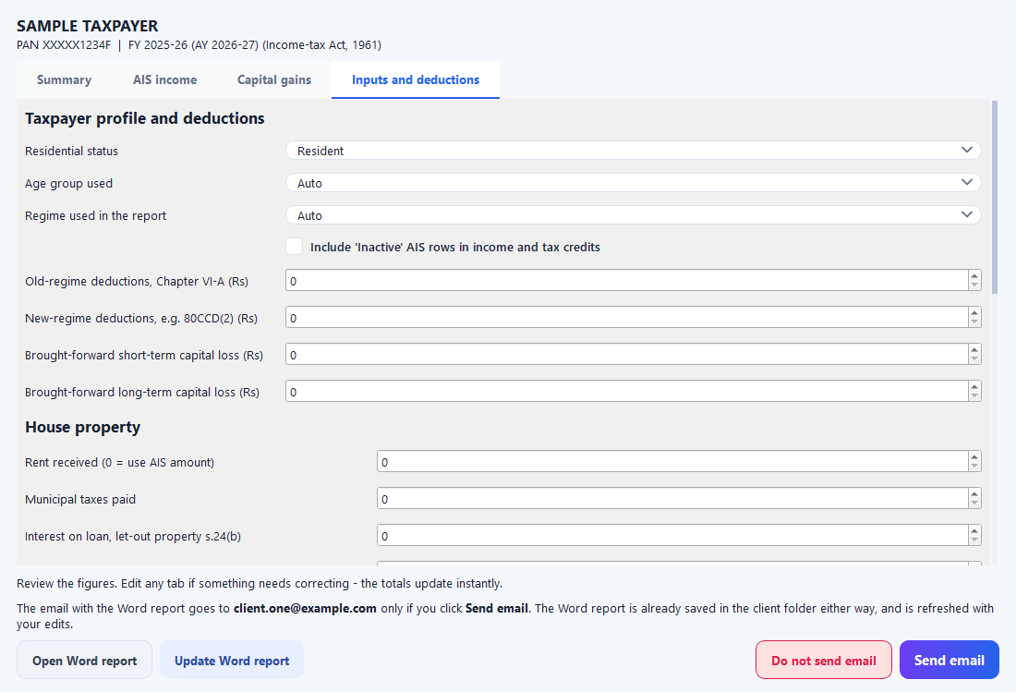
Figure 8: Review window - Inputs and deductions
Table 8: Taxpayer profile and deductions
Setting | What it does
Residential status | Resident, RNOR or Non-resident. Rebate and some slab benefits apply to residents.
Age group used | Auto uses the date of birth. Or choose Below 60, Senior (60-79) or Super senior (80+).
Regime used in the report | Auto picks the lower-tax regime. Choose Old or New to force one.
Include 'Inactive' AIS rows | Off by default. Inactive rows are those the system has superseded.
Old-regime deductions (Chapter VI-A) | Total of 80C, 80D and similar deductions, for the old regime.
New-regime deductions | For example 80CCD(2), for the new regime.
Brought-forward short-term / long-term capital loss | Losses of earlier years to set off against this year's gains.
Table 9: House property
Setting | What it does
Rent received | Annual rent. Leave 0 to use the AIS amount.
Municipal taxes paid | Deducted from the rent to get the net annual value.
Interest on loan, let-out property | Section 24(b) interest. A 30% standard deduction is applied automatically.
Interest, self-occupied property | Capped at Rs 2,00,000 and allowed in the old regime only.
Table 10: Business or profession
Setting | What it does
Computation method | AIS as reported; 44AD; 44ADA; 44AE; or Books (receipts less expenses).
Gross receipts | Leave 0 to use the AIS business amount. You must confirm these are real business receipts.
of which received digitally | For 44AD: 6% applies to digital receipts and 8% to the rest.
Expenses | For the Books method.
44AE vehicle-months / tonne-months | Rs 7,500 per light goods vehicle-month; Rs 1,000 per tonne-month for heavy vehicles.
44ADA takes 50% of receipts as income. TaxReady warns when receipts cross the limits for 44AB, 44AD or 44ADA; check eligibility yourself.
Table 11: Sale of land or building
Setting | What it does
Include a property sale | Tick to enter a sale of land or a building.
Sale consideration, cost of acquisition, cost of improvement, transfer expenses | The figures from the sale and purchase documents.
Financial year of acquisition | Used with the Cost Inflation Index for indexation.
Held more than 24 months | Long term. If unticked the gain is short term and taxed at slab rates.
Acquired before 23-Jul-2024 | For a resident, TaxReady compares 20% with indexation against 12.5% without and uses the lower tax.
Sold before 23-Jul-2024 | For FY 2024-25 only: 20% with indexation applies.
Exemption claimed s.54 / 54F | Deducted from the gain (capped at Rs 10 crore). Check the conditions and time limits yourself.

6.5 The buttons
Table 12: Review window buttons
Button | What it does
Open Word report | Refreshes the report with your edits and opens it in Word.
Update Word report | Rewrites the saved report with your edits. If the file is open in Word, close it first.
Do not send email | Closes the window without emailing. The report is saved, with your edits.
Send email | Updates the report, then lets the email go to the client.

A good review routine
Read the Points to review box; enter any missing purchase costs; confirm the partner receipts and business receipts; add known deductions; compare the two regimes; then click Send email.

7. Running many clients (batch)
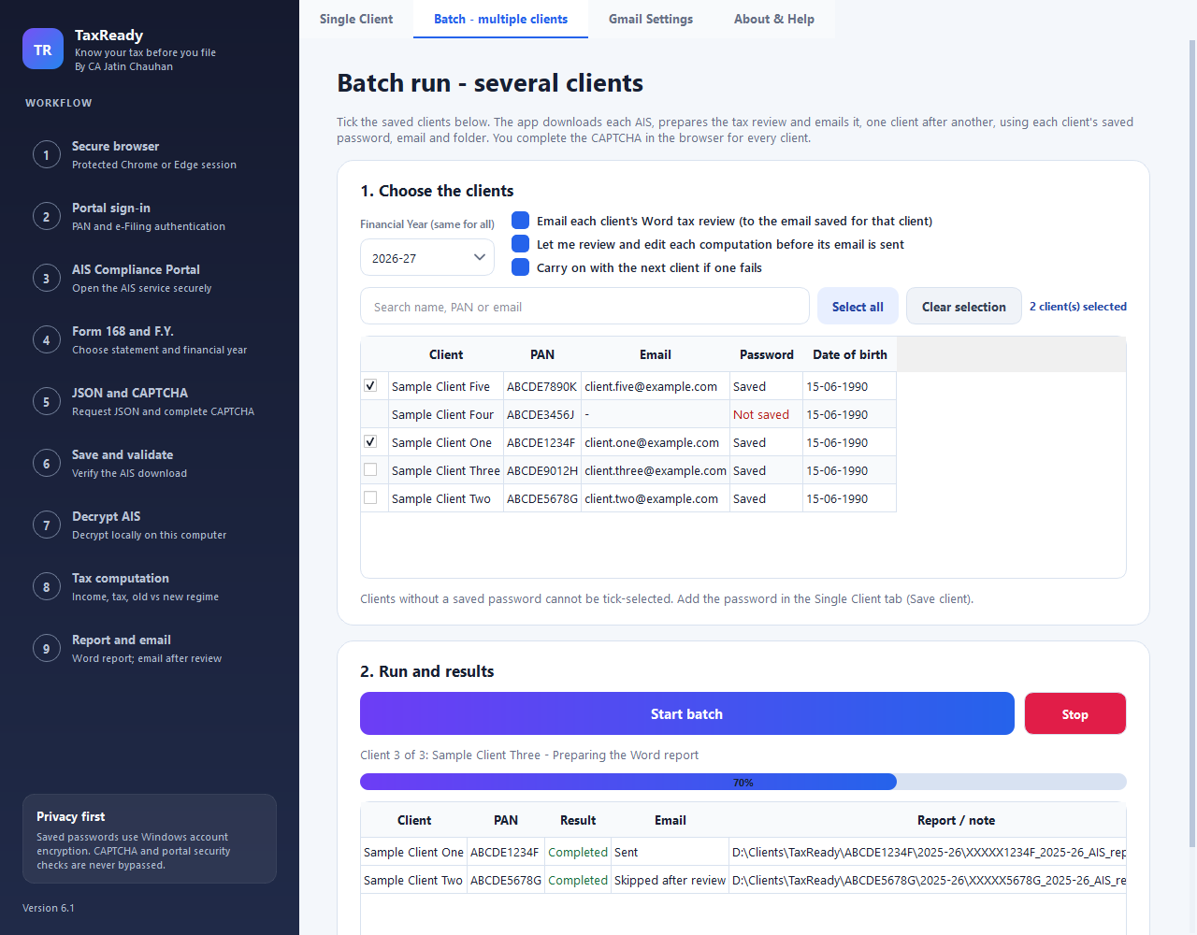
Figure 9: Batch tab with three clients ticked and the first two finished
1. Open the Batch - multiple clients tab.
2. Choose the Financial Year - it is the same for every client in the batch.
3. Tick the clients. Use the search box, Select all or Clear selection. Only clients with a saved password can be ticked.
4. Choose the options below, then click Start batch and confirm.
5. For each client in turn, a browser opens and you complete the CAPTCHA. TaxReady then decrypts, computes, saves the report and emails it.
6. At the end a summary shows the counts and the results table lists every client.
Table 13: Batch options
Option | Meaning
Email each client's Word tax review | Sends each report to the email saved for that client.
Let me review and edit each computation | Opens the review window for every client before its email is sent.
Carry on with the next client if one fails | Untick to stop the whole batch at the first failure.
Table 14: Batch results
Result | Meaning
Completed | The report was saved (and emailed if requested).
Completed - email failed | The report was saved but Gmail could not send it. Attach the saved file manually if needed.
Failed | The run could not finish. The reason is shown, and a downloaded AIS file is kept when possible.
Skipped | TaxReady did not start this client: no saved password, no valid email while emailing, or an unwritable folder.
Stopped | You pressed Stop during this client.
Not run | The batch ended before this client was reached.

Tip
Try a batch of two clients first, using your own email address for one of them, before running a large batch.

8. The Word report
The report is written for the client and for your file. It has a consistent layout, a masked PAN throughout, and the page numbers and the words “Confidential” in the header.
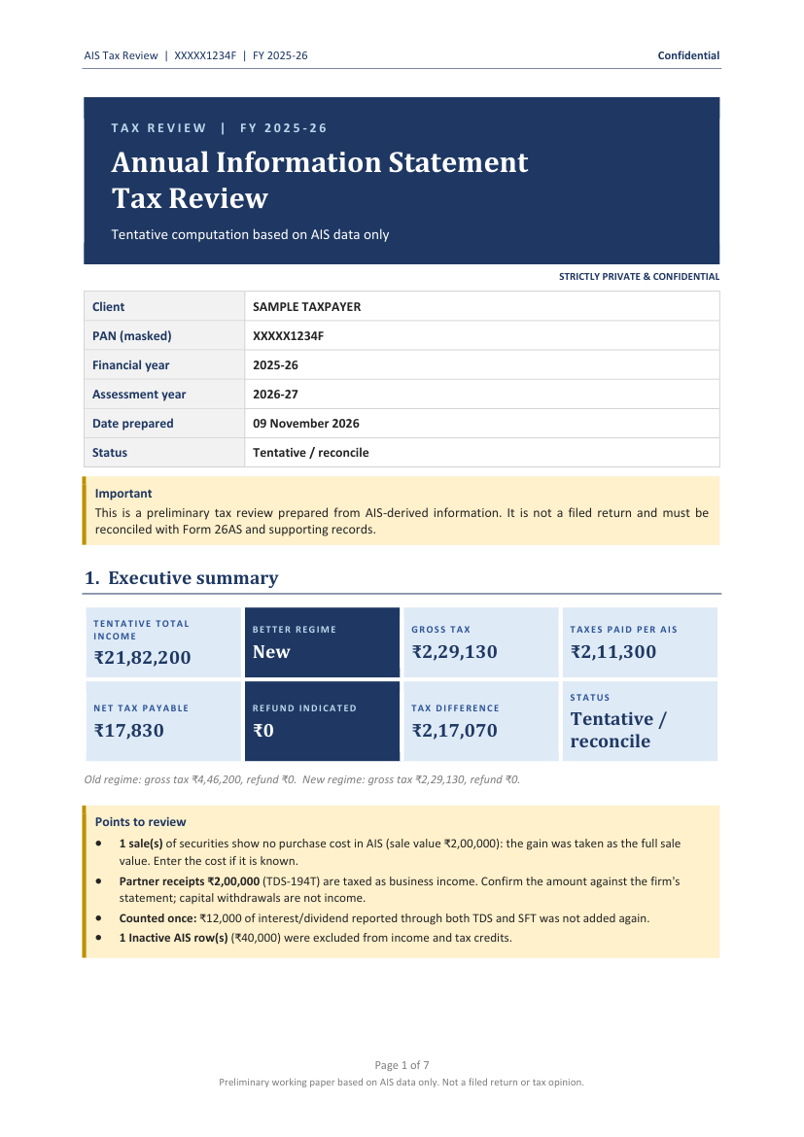 | 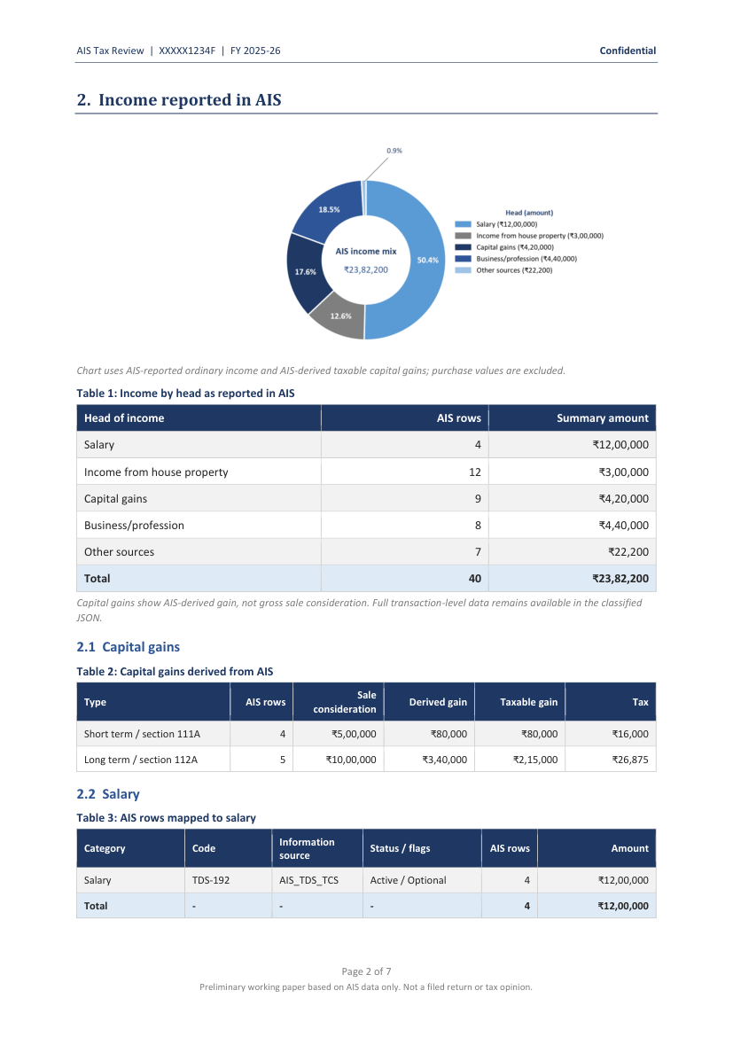
Figure 10: Report pages 1 and 2 (sample data)
Table 15: Sections of the Word report
Section | What it shows
Title band and details | Client name, masked PAN, financial year, assessment year, date prepared and status.
Important | A reminder that this is a preliminary review that must be reconciled with Form 26AS.
1 Executive summary | Eight tiles: Tentative total income, Better regime, Gross tax, Taxes paid per AIS, Net tax payable, Refund indicated, Tax difference between regimes, Status.
Points to review | The items to check first - for example sales with no purchase cost, partner receipts, rows left out.
2 Income reported in AIS | A chart and table of income by head, then capital gains, business and other sources, each row traced to its AIS code and source.
3 Taxes already paid / credited | TDS, TCS, advance tax and self-assessment tax as per the AIS, with a total.
4 High-value transactions | Information-only reports (such as purchases of securities) that the client may be asked to explain.
5 Unclassified items | AIS lines not mapped to a head of income.
6 Tentative tax computation | Old regime against new regime, the slab workings and the special-rate (capital gains) workings.
7 Documents required | A checklist of documents to collect, based on the income found.
8 Assumptions | Every assumption, override and reconciliation note, and the rate sources.
9 Annexure | Capital gains by transaction: date, security, section, quantity, sale value, purchase cost and gain.
- Amber rows are possible duplicate rows within one source. They are kept in the figures unless you excluded them.
- Data missing in AIS means a purchase cost was not shown; the gain was taken as the full sale value.
- Counted once means the same income was reported through both TDS and SFT and was added only once.

Always reconcile
The report states that it must be reconciled with Form 26AS and supporting records. Please do this before relying on any figure or filing the return.

9. The email the client receives
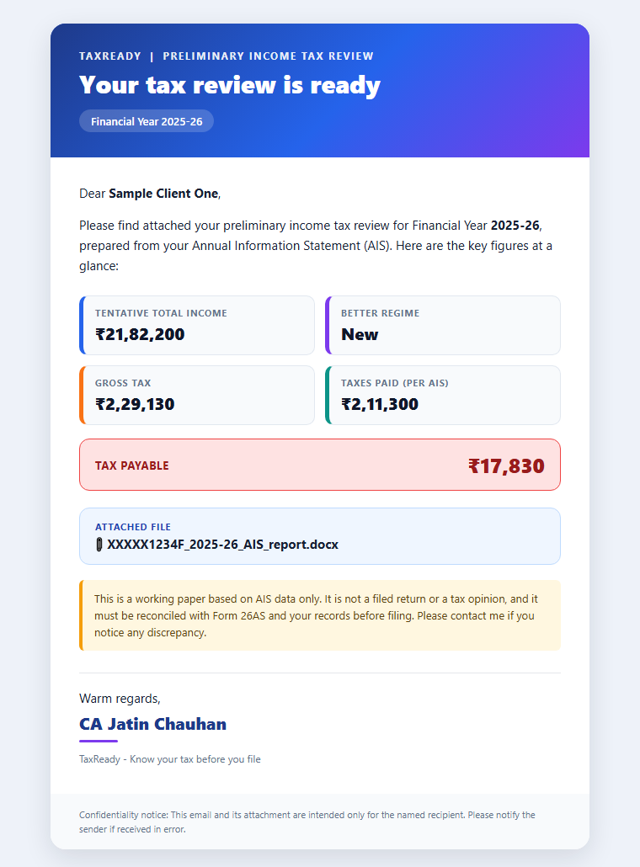
Figure 11: The email (sample data)
- Subject: Your Preliminary Income Tax Review - FY 2025-26 (the financial year you selected).
- A header, a greeting with the client's name and the key figures: tentative total income, better regime, gross tax and taxes paid.
- A green Refund indicated or red Tax payable banner with the amount.
- The Word report attached, a short disclaimer, and your signature: CA Jatin Chauhan - TaxReady, Know your tax before you file.
- A plain-text version is included for mail programs that cannot show the designed layout.

10. How the figures are worked out

10.1 Which AIS lines are used
- Only the AIS's own Active rows are used - the system-processed value. Inactive rows are left out unless you tick the option.
- Counted once: when the same income appears under both TDS and SFT (for example bank interest), the higher total is taken once and the other is shown as not added. If they are equal, the TDS line is kept because it carries the tax credit.
- Information-only reports (purchases of securities, cash deposits and similar) are shown under High-value transactions but are not income.
- Lines TaxReady does not recognise appear as Unclassified and are not counted until you assign a head.
- Payments from a partnership firm (TDS-194T) are treated as business income. Confirm the amount with the firm: capital withdrawals and the share of profit are not income.

10.2 Heads of income
Table 16: How AIS codes map to heads
Head | AIS lines mapped to it
Salary | TDS 192.
House property | Rent: TDS 194-I(A), 194-I(B), 194-IB, 194-IC.
Business/profession | TDS 194C, 194D, 194G, 194H, 194J, 194M, 194O, 194Q, 194R and 194T.
Other sources | Interest (TDS 194A, SFT-016), dividends (SFT-015, TDS 194, 194K) and similar.
Winnings | TDS 194B, 194BA, 194BB - taxed at 30% under section 115BB.
Capital gains | Sale of securities and units of mutual funds (SFT-17 sale reports).

10.3 Capital gains
- Gain = sale value - purchase cost, transaction by transaction, using the cost shown in the AIS (or the cost you enter).
- The AIS marks each sale as short term or long term, and TaxReady follows that. Long-term listed equity is taxed under section 112A and short-term listed equity under section 111A. Other long-term assets use section 112; other short-term gains are taxed at slab rates.
- For FY 2024-25 the 23 July 2024 change is handled: before that date 111A is 15%, 112A is 10% above Rs 1 lakh and 112 is 20%; from that date 111A is 20% and 112A and 112 are 12.5%, with a Rs 1.25 lakh exemption on 112A.
- Short-term losses are set off against short-term and then long-term gains; long-term losses only against long-term gains; then brought-forward losses.
- If the ordinary income is below the basic exemption, the shortfall is adjusted against the special-rate gains for a resident.
- The 31-January-2018 fair market value (grandfathering) is not applied; cost is taken as shown or as you enter it.

10.4 Tax computation
- Both regimes are computed with the slabs, standard deduction and rebate for the selected year (FY 2020-21 to Tax Year 2026-27).
- Rebate under section 87A is applied for residents, with marginal relief where the law provides it. Surcharge (with marginal relief) and 4% cess follow.
- Gross tax is rounded to the nearest Rs 10. Taxes paid are deducted to give the net tax payable or the refund.
- Tax already paid comes from the AIS: TDS and TCS deducted, advance tax and self-assessment tax challans.
Table 17: Key rules for FY 2025-26
FY 2025-26 (as set in the program) | New regime | Old regime
Standard deduction (salary) | Rs 75,000 | Rs 50,000
Basic exemption (below 60) | Rs 4,00,000 | Rs 2,50,000
Slabs | 5%, 10%, 15%, 20%, 25% up to Rs 24 lakh; 30% above | 5% to Rs 5 lakh; 20% to Rs 10 lakh; 30% above
Rebate 87A (residents) | Up to Rs 60,000 when total income is up to Rs 12 lakh | Up to Rs 12,500 when total income is up to Rs 5 lakh
Cess | 4% | 4%

Rates must be verified
The tax rates and thresholds in TaxReady were entered from public sources and are marked VERIFY. Check them against the Finance Act for the relevant year before relying on any figure.

11. Client register, history and themes

11.1 Activity history
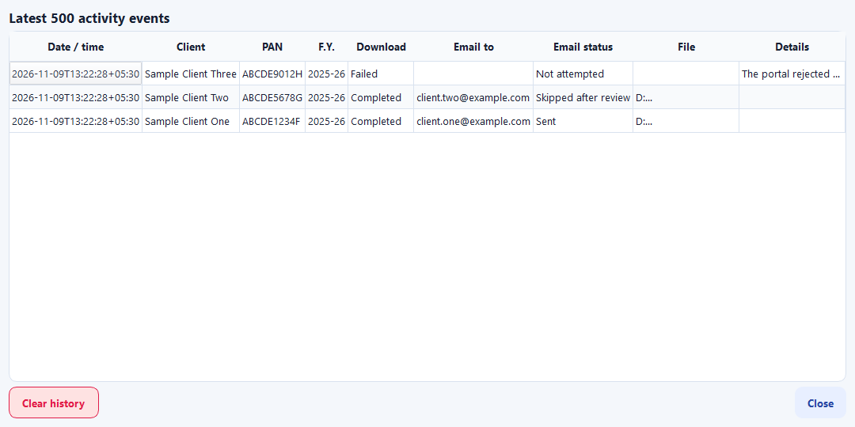
Figure 12: Activity history (sample data)
Click Activity history on the Single Client page to see the latest 500 events: date and time, client, PAN, financial year, result, email address, email status, report file and details. Clear history deletes all history records after confirmation. Saved clients and the Word reports are not affected.

11.2 Themes
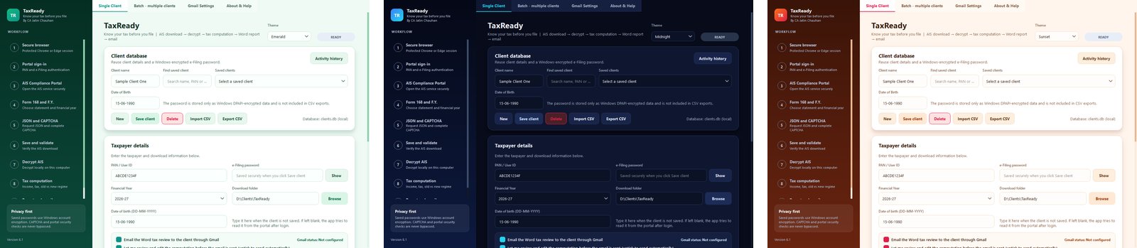
Figure 13: Three of the nine themes
Choose a theme from the Theme drop-down: Light, Dark, Ocean, Emerald, Royal Purple, Sunset, Rose Gold, Midnight or Graphite.

11.3 About & Help
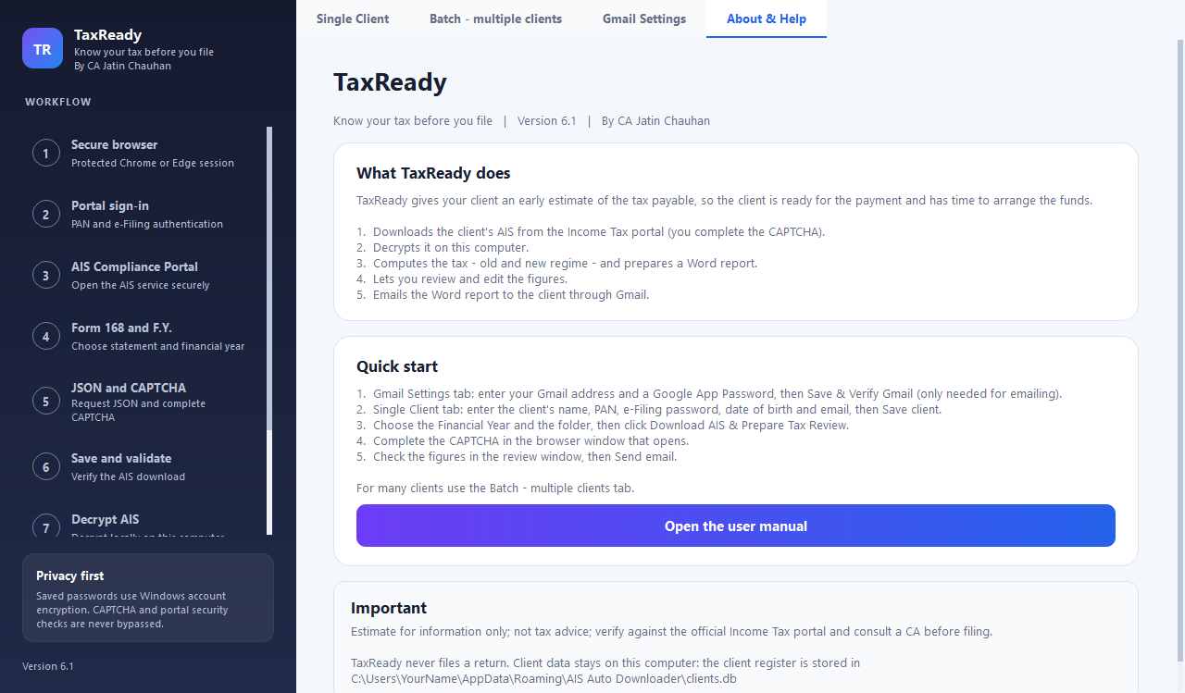
Figure 14: About & Help tab
Shows the version, a short explanation and a quick start. Open the user manual opens this manual if it is next to the program.

12. Privacy, security and where data is kept
- Everything runs on your computer. AIS data, PAN and dates of birth go only to the official portal and, if you choose, in the Gmail message to the client.
- Saved e-Filing passwords and the Gmail App Password are encrypted with Windows DPAPI: only the same Windows user on the same computer can read them. They are never logged, exported or kept in the temporary browser profile.
- The temporary browser profile, the downloaded AIS and the decrypted data are deleted after every run.
- The CAPTCHA and the portal's own security checks are never bypassed.
- The Word report file name uses a masked PAN.
Table 18: Where TaxReady keeps data
What | Where
Client register and activity history | %APPDATA%\AIS Auto Downloader\clients.db
Gmail sender, encrypted App Password and theme | Windows registry: HKEY_​CURRENT_​USER\Software\AIS Automation\AIS Auto Downloader
Word reports | The download folder you chose: <folder>\<PAN>\<financial year>\

Protect client data
Keep client reports and any CSV file that contains passwords in a secure place. Never put client data or reports on a public website or repository. To erase all saved clients, delete clients.db.

13. Troubleshooting
Table 19: Common problems
What you see | What to do
The portal says Permission Denied | Close any other automated portal windows, wait a minute and try again without a VPN or proxy.
Google Chrome or Microsoft Edge could not be started | Install Chrome or Edge, close other automated portal windows and retry.
The portal returned an HTML/error page instead of the AIS file | Keep the browser session open and retry the run.
Decryption failed | Check the PAN and the date of birth (DD-MM-YYYY) and run again. The downloaded file is kept for you.
The date of birth could not be read from the portal | Type the date of birth in the Date of birth box and run again.
The downloaded AIS is for a different financial year or PAN | Select the correct financial year, or check the PAN entered.
No rules for the financial year | Tax rules exist for FY 2020-21 to Tax Year 2026-27. Other years cannot be computed.
Saved password unavailable | The password was saved under another Windows account. Enter it again and click Save client.
Gmail connection failed | Check the sender address and use the 16-character App Password without spaces (not the normal password). Check the internet connection.
Report saved but email not sent | The report is safe in the client folder. Fix Gmail and attach the file manually if needed; the download need not be repeated.
The saved Word report is open in Word | Close the report in Word and click Update again.
A library cannot be installed | Run: pip install PyQt6 playwright python-docx matplotlib pycryptodome
The portal page changed and the download stops | The log shows the last completed stage. Portal layouts change; the program may need updating.

14. Frequently asked questions
Does TaxReady file the return?
No. It never files anything and does not touch any part of the portal except the AIS download.
Do I have to type the CAPTCHA?
Yes, every time. TaxReady never bypasses it.
Where does the date of birth come from?
TaxReady reads it from the portal after login. You can also type it, or save it with the client. It is the password for the encrypted AIS file.
Why is the report only a Word file?
To keep client data minimal. The downloaded and decrypted AIS files are deleted automatically.
Can I change the figures?
Yes. Use the review window to correct classifications, add purchase costs and enter deductions or other income. The report is refreshed with your edits.
Why was some income not added?
Either the same income was already counted through another source, or the row is Inactive. The Assumptions section and the Points to review box say which.
Why do some sales show a red row?
The AIS shows no purchase cost for them. Enter the cost if you have it.
Can I email without reviewing?
Yes. Untick the review option and the email is sent automatically, in single and in batch runs.
Which years are supported?
FY 2020-21 to Tax Year 2026-27.
Is the data sent anywhere?
No. It stays on your computer, apart from the portal login and the optional Gmail message.

15. Limitations and disclaimer
- Tax rates and thresholds were entered from public sources and are marked VERIFY.
- Interest under sections 234A, 234B and 234C and the fee under 234F are not computed.
- Debt mutual funds, unlisted shares and property sales reported by the AIS use a best-effort section mapping; check them.
- Grandfathering is not applied; purchase cost is taken as shown or as you enter it.
- TaxReady works from the AIS only. It cannot know deductions, exemptions or income that are not in the AIS unless you enter them.
- Windows only. If the portal changes its page layout, the download step may need updating.

Disclaimer
TaxReady is provided as is, without warranty of any kind. It produces a preliminary working paper from AIS data only. It is not a filed return, tax advice or a professional opinion. Verify against the official Income Tax portal and consult a Chartered Accountant before filing.

Appendix A Glossary
Table 20: Glossary
Term | Meaning
AIS | Annual Information Statement - the taxpayer's statement of income and transactions reported to the Income Tax Department.
PAN | Permanent Account Number. TaxReady shows it masked (XXXXX1234F) in reports.
FY / AY | Financial year (for example 2025-26) and the assessment year that follows it (2026-27).
TDS / TCS | Tax deducted / collected at source. Credit for it is taken in the computation.
SFT | Specified Financial Transaction - information reported by banks, brokers and others.
Old / new regime | The two tax systems. TaxReady computes both and recommends the lower tax.
87A rebate | A tax rebate for residents with total income up to a limit.
Surcharge, cess | Extra tax at higher incomes; 4% health and education cess on the total.
STCG / LTCG | Short-term and long-term capital gains.
Section 111A / 112A / 112 | Special tax rates for listed-equity short-term gains, listed-equity long-term gains and other long-term gains.
44AD / 44ADA / 44AE | Presumptive taxation schemes for small businesses, professionals and transport operators.
Inactive row | An AIS line that the system no longer treats as valid (for example superseded). Left out by default.
Form 26AS | The tax credit statement. The report must be reconciled with it.
CAPTCHA | The check on the portal that you solve yourself.
App Password | A 16-character password created in your Google account for programs such as TaxReady. It is not your Gmail password.
DPAPI | Windows data protection used to encrypt saved passwords.

Appendix B Client CSV layout
Save a file with this layout and use Import CSV. The first two lines below are the header and one example row (fake data).
Table 21: Example rows for the client CSV
Client Name | PAN | Email | Date of Birth | Password | Download Folder
Sample Client One | ABCDE1234F | client.one@example.com | 15-06-1990 | - | -
Sample Client Two | ABCDE5678G | client.two@example.com | 02-11-1985 | - | D:\Clients\SampleTwo

Appendix C Checklist before you send a report
- The correct financial year was selected, and the report shows the right client and masked PAN.
- Every red row in Capital gains has a purchase cost, or you have noted why it is nil.
- Partner receipts, business receipts and any Unclassified items have been confirmed.
- Rows left out (Inactive or counted once) agree with your records.
- Known deductions, house property, losses and exemptions have been entered.
- The result has been compared with Form 26AS and the client's records.
- The client email address is correct.

